Perform hands-on implementation in AWS.

AWS Lambda - AWS API Gateway - AWS KMS (Key Management Service)

1: What is AWS Lambda?
AWS Lambda is a serverless compute service. With Lambda, you can run code without provisioning or managing servers. Lambda automatically manages the underlying infrastructure – including server maintenance, capacity provisioning, scaling, and patching – so you can focus on your application logic.

1. AWS Lambda
Objective:
To create and test a serverless AWS Lambda function.
Implementation:
- Opened AWS Lambda console.
- Created a function named majeed-lambda-demo.
- Selected Python 3.14 runtime.
- Used the default execution role.
- Added Python Lambda handler code.
- Created a test event containing a name.
- Invoked the Lambda function.
- Verified successful execution and response.
Result:
Hello Majeed from AWS Lambda!
Observation:
Lambda allows code to run without provisioning or managing EC2 servers.

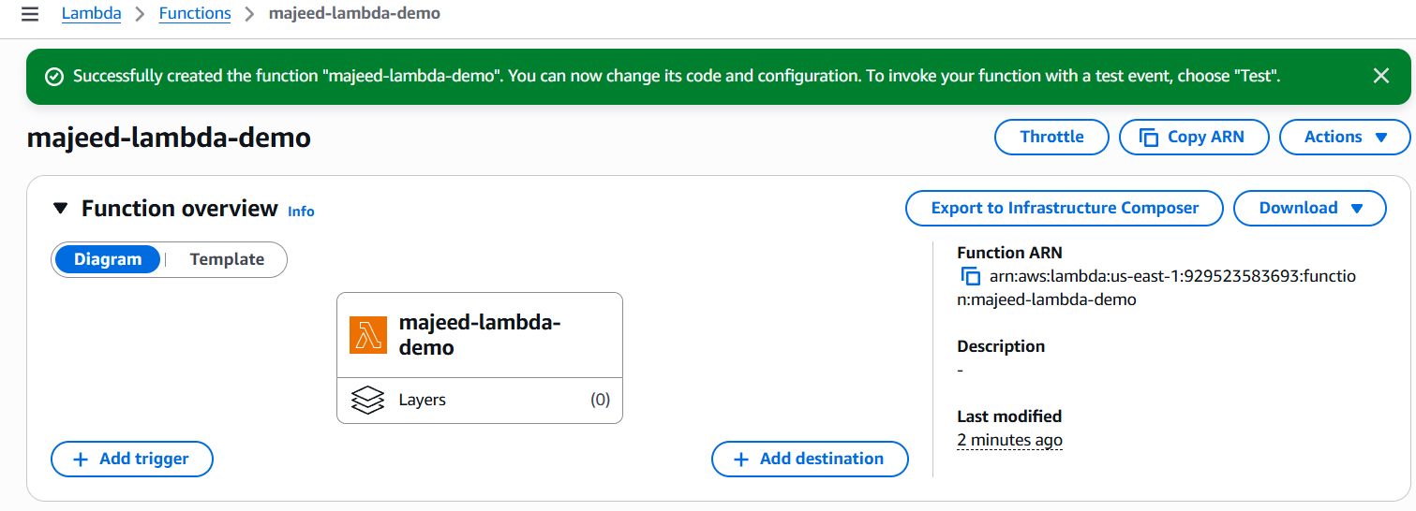
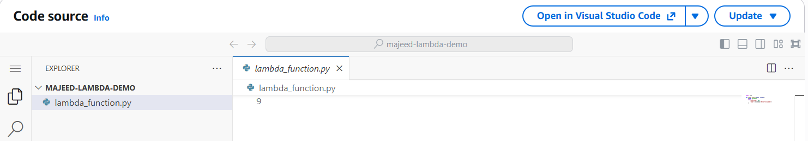
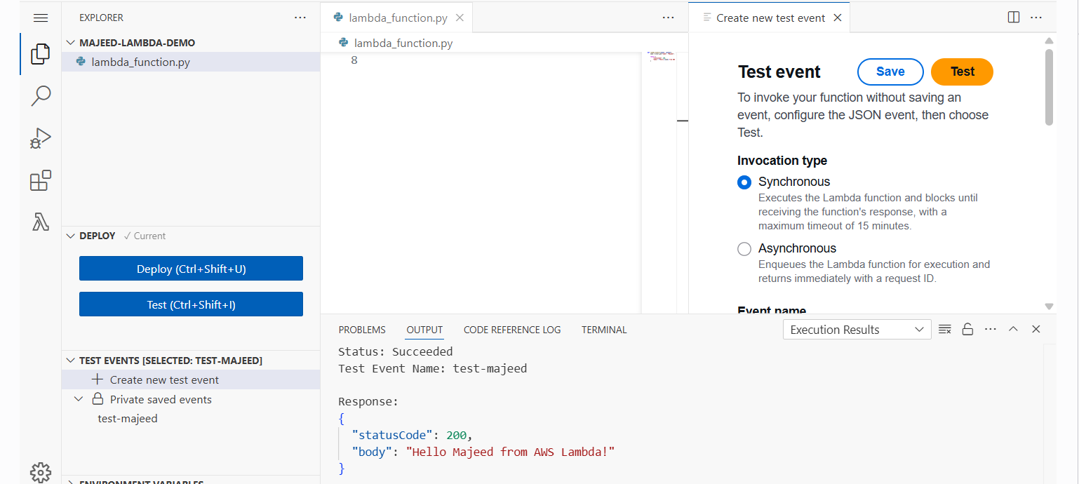

2: What is Amazon API Gateway?
Amazon API Gateway is an AWS service for creating, publishing, maintaining, monitoring, and securing REST, HTTP, and WebSocket APIs at any scale. API developers can create APIs that access AWS or other web services, as well as data stored in the AWS Cloud. As an API Gateway API developer, you can create APIs for use in your own client applications. Or you can make your APIs available to third-party app developers.

1. Create HTTP API
- Open AWS Management Console.
- Search for API Gateway.
- Click Create API.
- Under HTTP API, click Build.
- Enter API name:
majeed-lambda-api
- Select IPv4 as the IP address type.
2. Configure Lambda Integration
- Under Integrations, select Lambda.
- AWS Region:
us-east-1
- Select Lambda function:
majeed-lambda-demo
- Keep the Lambda payload format version:
2.0
- Click Next.
3. Configure Route
- Click Add route.
- Select Method:
GET
- Resource path:
/
- Integration target:
majeed-lambda-demo
- Click Next.
The route is:
GET / → majeed-lambda-demo
4. Configure Stage
- Keep the default stage:
$default
- Keep Auto-deploy enabled.
- Click Next.
5. Review and Create
Verify:
- API Name: majeed-lambda-api
- IP Address: IPv4
- Integration: majeed-lambda-demo
- Route: GET /
- Stage: $default
- Auto-deploy: Enabled
Click Create.
6. Test the API
- Open the API Gateway Stages section.
- Select $default.
- Copy the Invoke URL.
- Open the Invoke URL in a web browser.
Example:
https://1mk2eis3ng.execute-api.us-east-1.amazonaws.com
7. Verify Response
The browser returned:
Hello Majeed from AWS Lambda!
This confirms that API Gateway successfully invoked the Lambda function.
Architecture
Browser/User
↓
API Gateway HTTP API
↓
GET /
↓
AWS Lambda (majeed-lambda-demo)
↓
Response: Hello Majeed from AWS Lambda!
Result
Successfully created and tested an API Gateway HTTP API integrated with AWS Lambda.
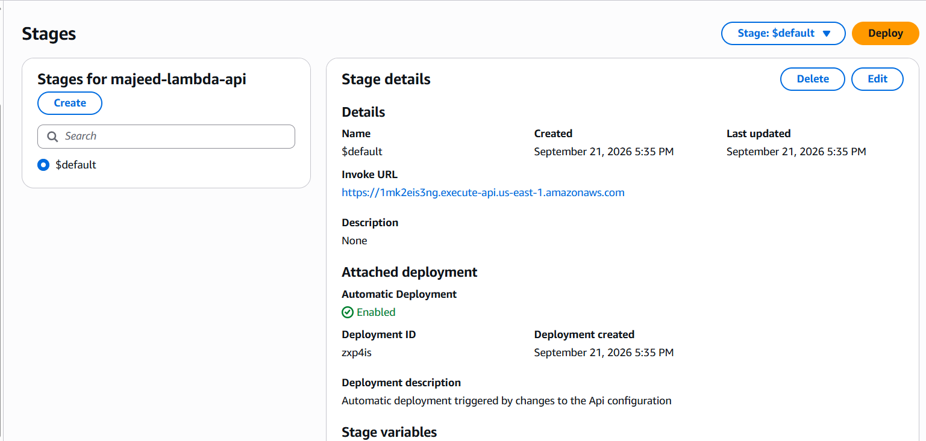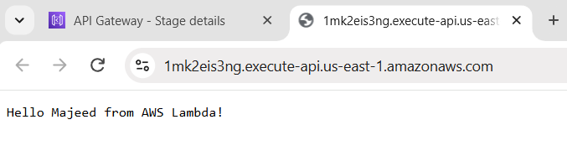
3: AWS Key Management Service (KMS)
AWS Key Management Service (AWS KMS) is an AWS managed service that makes it easy for you to create and control the keys used to encrypt and sign your data. The AWS KMS keys that you create in AWS KMS are protected by FIPS 140-3 Security Level 3 validated hardware security modules (HSM). They never leave AWS KMS unencrypted. To use or manage your KMS keys, you interact with AWS KMS.
Why use AWS KMS?
When you encrypt data, you need to protect your encryption key. If you encrypt your key, you need to protect its encryption key. Eventually, you must protect the highest level encryption key (known as a root key) in the hierarchy that protects your data. That's where AWS KMS comes in.
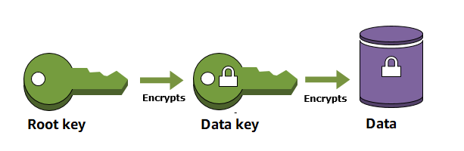
1. Objective
To create and configure a customer-managed AWS KMS key and test encryption and decryption using AWS CLI.
2. Architecture
User / AWS CLI
|
v
IAM User (kms-cli-user)
|
v
AWS KMS
|
+---- Encrypt ----> Encrypted Data
|
+---- Decrypt ----> Original Data
3. KMS Key Configuration
Created a customer-managed KMS key with the following configuration:
- Key type: Symmetric
- Key specification: SYMMETRIC_DEFAULT
- Key usage: Encrypt and decrypt
- Key origin: AWS KMS
- Regionality: Single-Region
- Alias: majeed-kms-key
- Description: KMS key for hands-on encryption testing
- Key state: Enabled
- Automatic key rotation: Enabled
- Rotation period: 365 days
4. Create KMS Key
- Open AWS Management Console.
- Go to KMS (Key Management Service).
- Select Customer managed keys.
- Click Create key.
- Select:
  - Symmetric
  - SYMMETRIC_DEFAULT
  - Encrypt and decrypt
  - AWS KMS
  - Single-Region
- Add the alias:
majeed-kms-key
- Add description:
KMS key for hands-on encryption testing
- Leave the administrator and key-user selections empty initially.
- Keep the default key policy.
- Review the configuration.
- Click Finish to create the key.
5. Verify KMS Key
The key was verified using AWS CLI:
aws kms describe-key --key-id alias/majeed-kms-key
Important output confirmed:
Enabled: true
KeyState: Enabled
KeyUsage: ENCRYPT_DECRYPT
KeySpec: SYMMETRIC_DEFAULT
Origin: AWS_KMS
KeyManager: CUSTOMER
MultiRegion: false
6. Enable Automatic Key Rotation
- Open the KMS customer-managed key.
- Go to Key material and rotations.
- Click Edit.
- Enable automatic key rotation.
- Keep the rotation period at 365 days.
- Save the changes.
Result:
Rotation status: Enabled
Rotation period: 365 days
7. Configure Key User
During encryption testing, the IAM user initially did not have permission to use the KMS key.
Added:
IAM User: kms-cli-user
Under:
KMS → Customer managed keys → majeed-kms-key → Key policy → Key users
After adding the user:
Key users: 1
kms-cli-user
8. Prepare Plaintext File
Moved to the user's home directory:
cd ~
Created a plaintext file:
echo "Hello Majeed from AWS KMS!" > plaintext.txt
Verified the file:
cat plaintext.txt
Output:
Hello Majeed from AWS KMS!
9. Encrypt the Data
The plaintext was encrypted using the KMS key:
aws kms encrypt --key-id alias/majeed-kms-key --plaintext fileb://plaintext.txt --output text --query CiphertextBlob > encrypted.txt
The command generated Base64-encoded ciphertext.
The ciphertext was converted into a binary encrypted file using PowerShell:
powershell.exe -Command "[IO.File]::WriteAllBytes('encrypted.bin',[Convert]::FromBase64String((Get-Content encrypted.txt -Raw)))"
Verified the encrypted file:
ls -lh encrypted.bin
Result:
encrypted.bin
179 bytes
The encrypted.bin file represents the encrypted ciphertext.
10. Decrypt the Data
The encrypted file was passed to AWS KMS for decryption:
aws kms decrypt --ciphertext-blob fileb://encrypted.bin --output text --query Plaintext | base64 --decode
Decrypted output:
Hello Majeed from AWS KMS!
This confirmed that the encrypted data was successfully decrypted back to the original plaintext.
11. Errors Encountered and Fixes
Error 1 – Permission denied
Error:
bash: plaintext.txt: Permission denied
Cause:
Git Bash was in the / root directory and did not have permission to create the file.
Fix:
cd ~
Then the file was created successfully.
Error 2 – KMS AccessDeniedException
Error:
AccessDeniedException:
User is not authorized to perform: kms:Encrypt
Cause:
kms-cli-user was not configured as a key user for the KMS key.
Fix:
Added kms-cli-user under:
KMS → Key policy → Key users
After this, the user was able to perform encryption.
Error 3 – Base64 invalid input
Error:
base64: invalid input
Cause:
Git Bash's Base64 utility had an issue processing the AWS CLI Base64 output.
Fix:
Used PowerShell to convert the Base64 ciphertext into the required binary file:
powershell.exe -Command "[IO.File]::WriteAllBytes('encrypted.bin',[Convert]::FromBase64String((Get-Content encrypted.txt -Raw)))"
Error 4 – InvalidCiphertextException
Error:
InvalidCiphertextException
Cause:
The Base64-encoded ciphertext was supplied directly to KMS instead of the decoded binary ciphertext.
Fix:
Converted the Base64 ciphertext into encrypted.bin and used:
aws kms decrypt --ciphertext-blob fileb://encrypted.bin ...
The decryption then succeeded.
Final Base64 message
After successful decryption, Git Bash displayed:
Hello Majeed from AWS KMS!
base64: invalid input
The KMS decryption itself was successful because the original plaintext was returned correctly. The additional message was generated by the local Git Bash Base64 command.
12. Observations
- AWS KMS securely manages encryption keys.
- A customer-managed key provides control over key configuration and rotation.
- Symmetric KMS keys can be used for encryption and decryption.
- IAM permissions and KMS key policies both play a role in allowing users to use a KMS key.
- Automatic key rotation can be enabled to periodically rotate key material.
- The encrypted ciphertext cannot be directly read as normal text.
- KMS successfully converted the encrypted ciphertext back to the original plaintext during decryption.
13. Final Result
AWS KMS implementation completed successfully.
KMS Key Creation → Successful
Key Configuration → Successful
Key Rotation → Enabled
IAM Key User → Configured
Encryption → Successful
Decryption → Successful
Original Data Verified → Successful
Final decrypted message:
Hello Majeed from AWS KMS!
Task 3 – AWS KMS: COMPLETED ✅
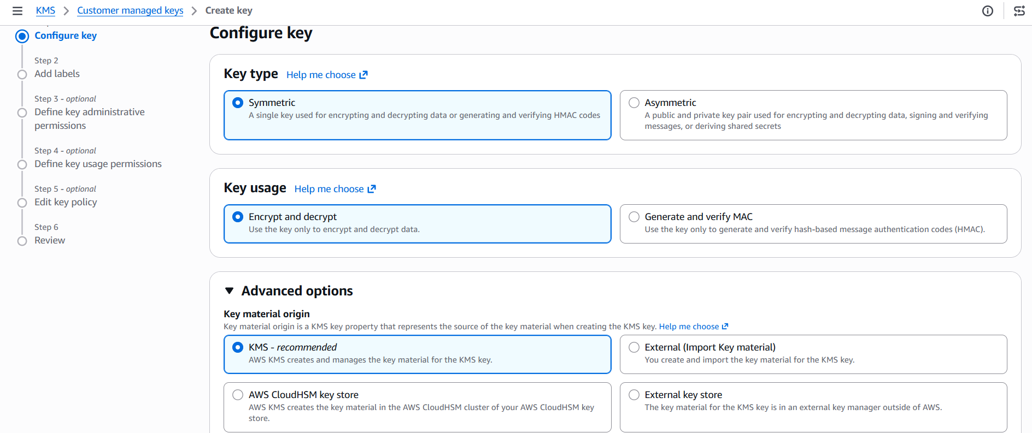
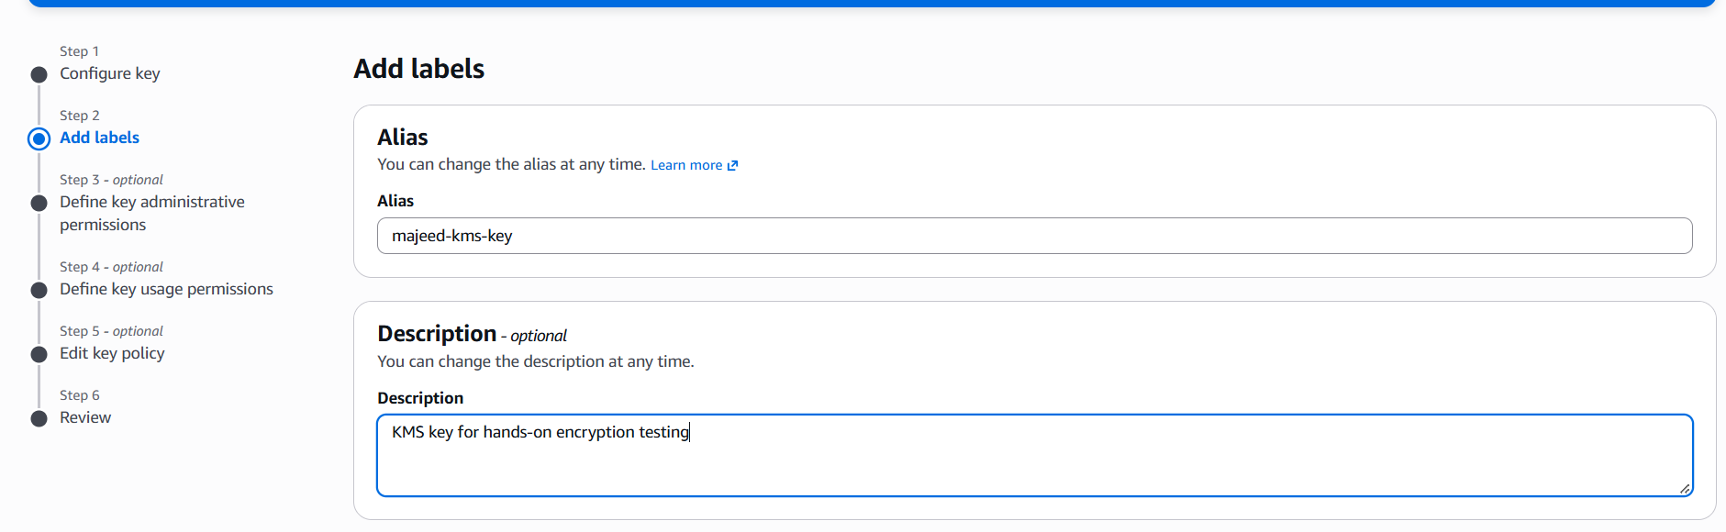

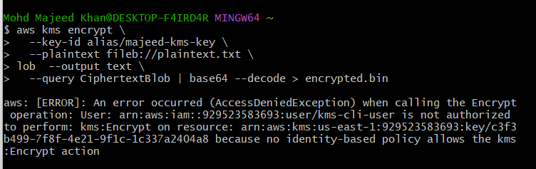
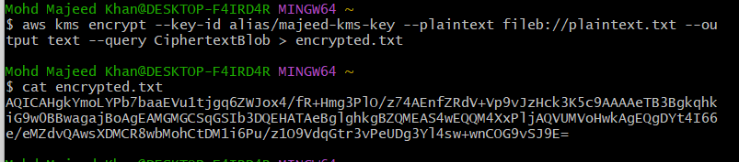
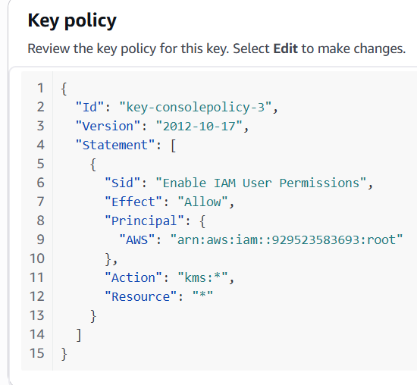
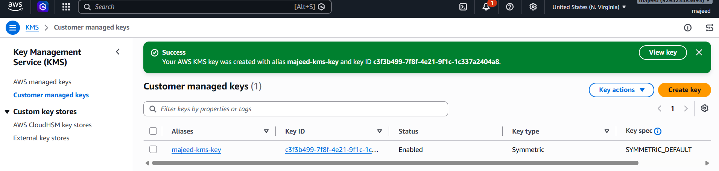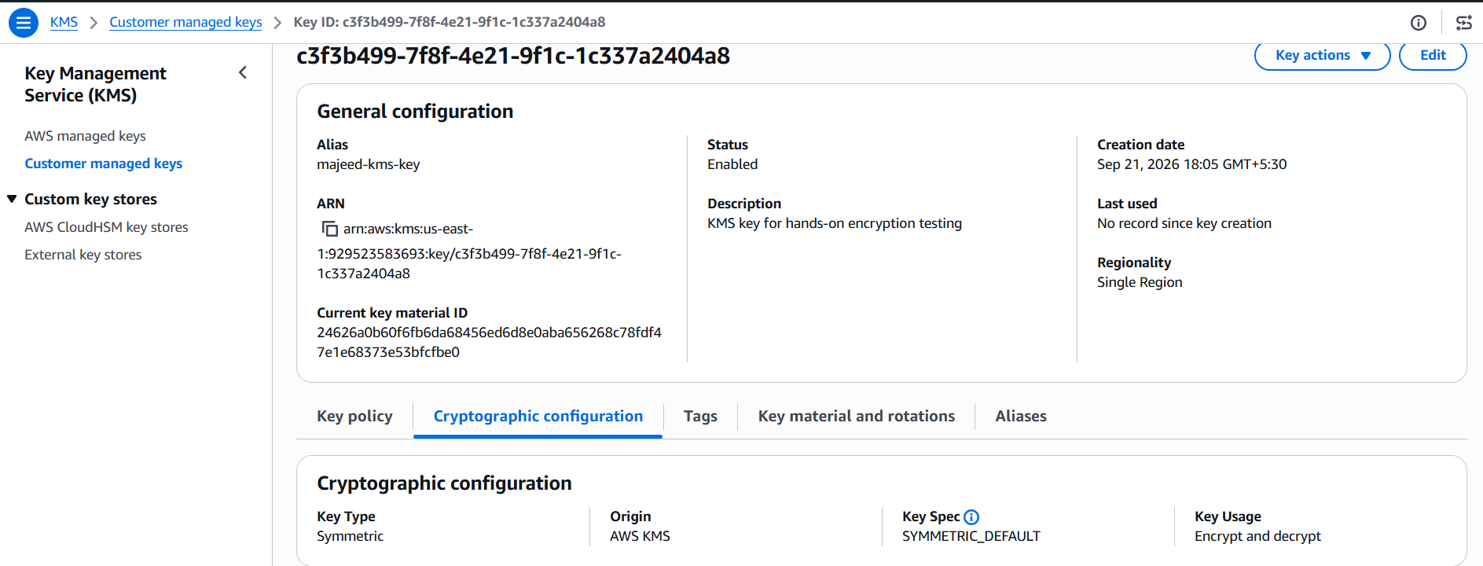
automatic key rotation is currently Disabled change to Enabled.
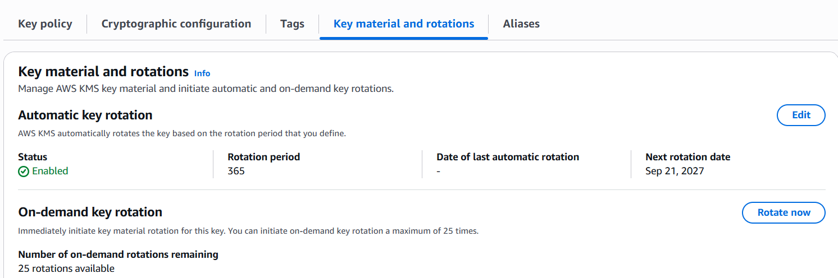
Error:
Resolve by adding the Cli User under customer managed keys.
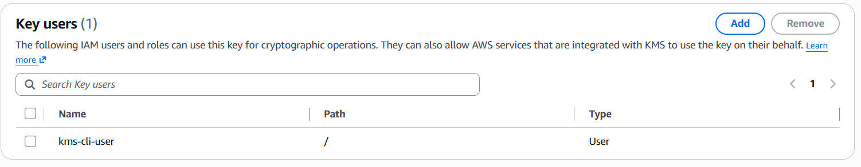
Encryption succeeded
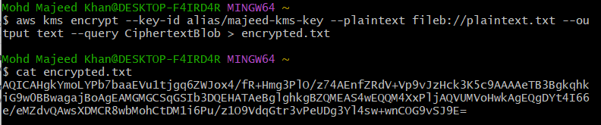

Error facing in the encryption is definitely working. The issue is only the Base64 decoding in Git Bash. And the base64: invalid input is coming from the Git Bash base64 command, not from AWS KMS.
Tested decryption
